Explanation of Notation Practices

right hand fingering

p – thumb
i – index finger
m – middle finger
a – ring finger
c – little/pinky finger
left hand fingering

1 – first/index finger
2 – second/middle finger
3 – third/ring finger
4 – fourth/little finger
t – thumb
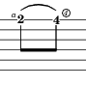  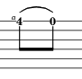 | slur (ascending/hammer-on and descending/pull-off)

